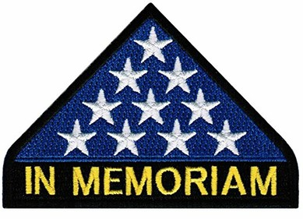

First Platoon  Richard S. Brennan III  John R. Brownell  Kenton Keith Cecil  Jerry W. Fisher  Thomas A. Gilbride  Kirby L. Kirkland Jr.  Stanley L. Lapidow  Francis P. McLaughlin Jr.  John M. Richards | Second Platoon  Richard P. Coburn Jr  Charles H. Cochran  Michael E. Doggett  James P. Greenlee  David H. Heffner  Paul W. Hogue  ﻿ Robert A. Lawhon﻿  ​  William T. Morris  James E. Sundstrom  Dale A. Wardlaw  Charles R. Ware

