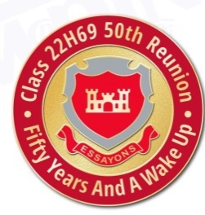
SITREP #2
Date of Issue – 12 Jan 19
Functional Area - Transportation

Situation To Date:

The planning team considered having the Saturday night banquet at the Officers Club at Fort Belvoir or Joint Base Myer-Henderson Hall. Either of these sites would have required the rental of a large passenger bus. After discussion and analysis the banquet will be held at the hotel negating that cost of travel.

Actions To Date:

We are researching transportation options from the hotel to the National Mall Area and other possible tour sites. Transportation options include shuttles, metro stations, vans, and buses.

Actions To Be Completed:

Once a complete itinerary has been finalized - transportation options and schedules will be given to attendees.

Issue(s):

- Need to identify anyone with physical challenges to provide appropriate travel accommodations

- Planning for transportation cannot be completed until a complete event itinerary is finalized

Prepared By: Jim Wilson

