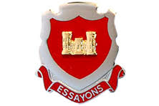

United States Army
Engineer Officer Candidate Regiment
Fort Belvoir, Virginia

3 March – 8 August, 1969
106 Commissioned Lieutenants
“Let Us Strive”

