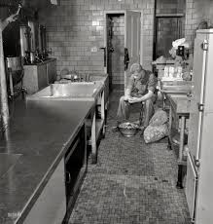

KP duty is "kitchen police" or "kitchen patrol" work under the kitchen staff assigned to junior U.S. enlisted military personnel. "KP" can be either the work or the personnel assigned to perform such work.
Duties include: Side Sink (emptying, washing and drying trays, cups, and silverware), Outside (scrubbing pots and pans and cleaning grease traps) Food Prep, Back Sink, Dining Room Orderly (DRO) (waiting on tables) and always mopping floors and cleaning tables.

