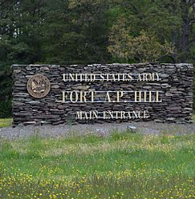

Going to Fort A.P. Hill, Virginia’s field training area, 50 miles south of Fort Belvoir during the ninth week of training was a “water mark” for candidates, because it afforded them an opportunity to get away from the routine of being in USAEOCR at Fort Belvoir. It was also the first time they would live as an Infantry soldier in an OCS field training environment. During that week, candidates were instructed in weapons: including firing the M-14 rifle, 3.5 inch rocket launcher, M-60 machine gun, M-79 grenade launcher and .45 caliber pistol. Infantry tactics played a key role with a focus on squad and platoon operations. One of the “highlights” of the week was “The Escape and Evasion Course.”

