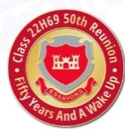
AFTER ACTION REPORT

EOCR CLASS 22 HOTEL 69

50 YEAR REUNION

Sheraton Pentagon City Hotel
Arlington, Virginia
3 – 6 October, 2019

Submitted By: Reunion Planning Team
Gary Cochard
Jeff Ellis
Chuck Engelberger
Kit Kitson
Glenn McCarley
Joe Tavares
Jim Wilson

23 October, 2019

