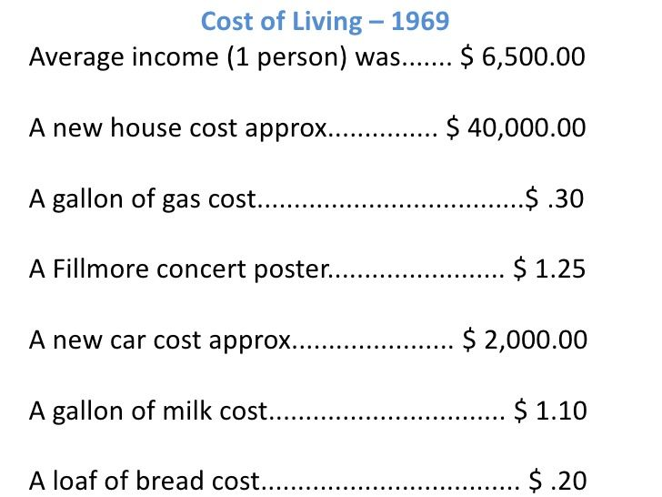

COST OF LIVING – 2019
Average Income (1 Person) $26,093
New House Cost $380,900
One Gallon Of Gas Cost $2.79
A New Car Cost $35,742
A Gallon Of Milk Cost $3.27
A Loaf Of Bread Cost $2.92

