[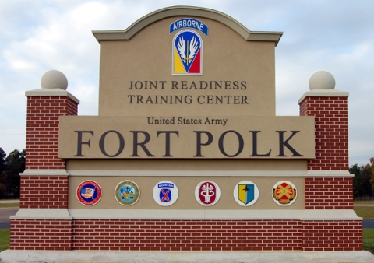](https://www.google.com/url?sa=i&rct=j&q=&esrc=s&source=images&cd=&cad=rja&uact=8&ved=0ahUKEwjk2ovT8-jVAhWDQSYKHd2bB1wQjRwIBw&url=https://militarybases.com/fort-polk-army-base-in-vernon-parish-la/&psig=AFQjCNEZ_JUZ618ML2N2YufWMRhNfqgJ_w&ust=1503424618482338)

[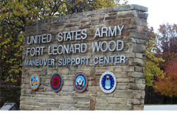](http://www.google.com/url?sa=i&rct=j&q=&esrc=s&source=images&cd=&cad=rja&uact=8&ved=0ahUKEwiRzpOP9ejVAhUCRyYKHfs9C3AQjRwIBw&url=http://www.mpraexpo.com/Travel/Hotel&psig=AFQjCNFrZ-eFSDIogQA7jIGCvDg5N3gzGw&ust=1503425013933990)

[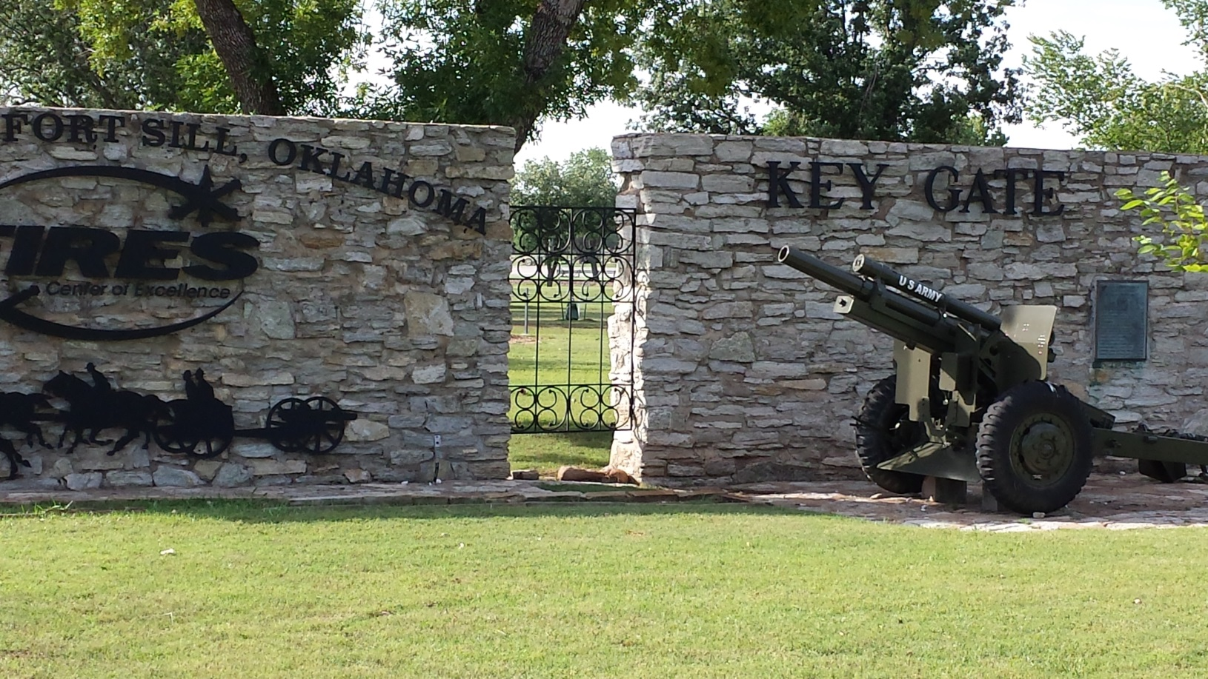](http://www.google.com/url?sa=i&rct=j&q=&esrc=s&source=images&cd=&cad=rja&uact=8&ved=0ahUKEwiDj4O9-OrVAhUE1CYKHXOfBPUQjRwIBw&url=http://www.krmg.com/news/local/bridenstine-visit-sill-plans-ask-questions-despite-restrictions/fPZtZOIWMnvbyJ6n7l8KhP/&psig=AFQjCNHYfiB-eXx1GsGvDpLpPt8SL9VPDQ&ust=1503494698648077)